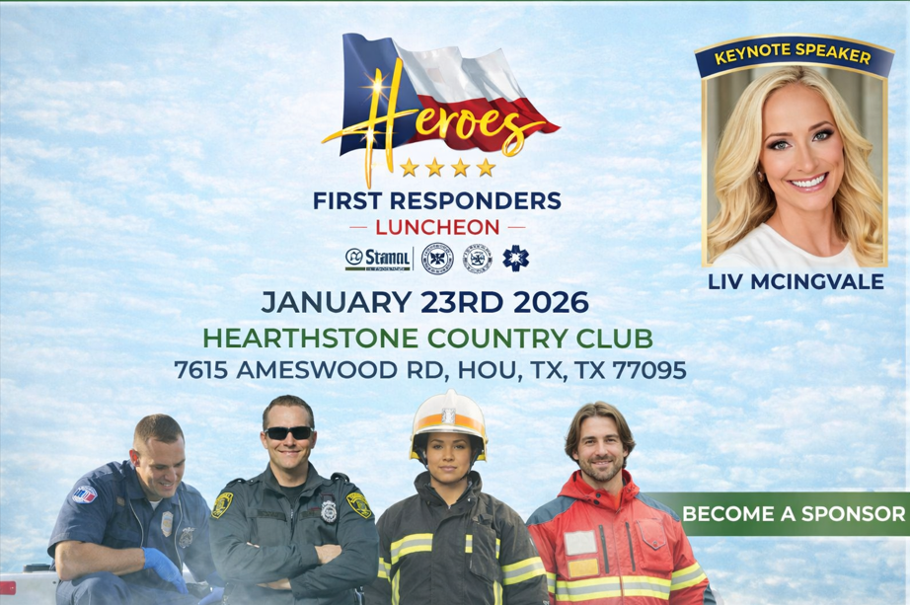

c

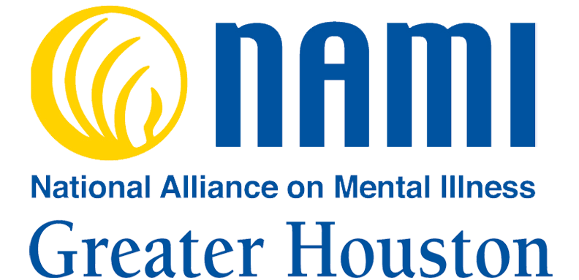
Dr. Elizabeth McIngvale

2026 Heroes of Hope Luncheon & Frontline Wellness Initiative
The Opportunity
Partner with NAMI Greater Houston as a corporate sponsor of the 2026 Heroes of Hope Luncheon, an annual leadership event honoring CIT Officers and frontline first responders and directly funding NAMI’s Frontline Wellness Initiative—a peer-led mental health program designed to protect those who protect our communities. The Frontline Wellness Initiative includes: Awareness presentations for law enforcement, hospitals, clinics, firefighters and EMS personnel. The program also includes a warmline staffed by peers in the first-responder professions and a certification training to become an Overwatch Peer Support.
This partnership allows your organization to make a measurable investment in public safety, workforce wellness, and community resilience in one of the largest and most complex regions in the nation.

Why This Aligns with Corporate CSR & ESG Priorities
1. Workforce Wellness & Mental Health
First responders face chronic exposure to trauma, stress, and crisis decision-making. Frontline Wellness delivers peer-led, trauma-informed training and support that reduces burnout, improves resilience, and encourages early intervention—outcomes that mirror corporate commitments to employee well-being and mental health.
2. Public Safety & Community Impact
In Harris County, first responders are often the first—and sometimes only—mental health responders. Supporting their wellness leads to safer crisis responses, better de-escalation outcomes, and stronger trust between public safety and the communities they serve.
3. Equity, Access & Systems Strengthening
Frontline Wellness improves how mental health crises are handled across diverse communities by equipping responders with skills that reduce harm, stigma, and unnecessary system involvement—advancing equity and responsible community engagement.
4. Reputational Leadership
Sponsors are publicly recognized as champions of frontline workers and community mental health. This high-visibility event demonstrates authentic corporate leadership rooted in action, not just messaging.

Why Peer-Led Support Works
Peer support is proven to be one of the most effective models for first responders. Individuals are more likely to engage, trust, and seek help from peers who understand the realities of the job. This approach reduces stigma, strengthens follow-through, and creates sustainable wellness infrastructure within agencies. In our service area, we have witnessed losing talented professionals in the first responder community despite having access to insurance, department psychiatrists and psychologists, and EAP services. Peer support moves intervention in closer proximity to emerging mental health issues among the ranks.

The Impact in Harris County
Your sponsorship helps deliver:
- Safer, more effective mental health crisis responses, confidential and trusted
- Reduced burnout, turnover, and staffing shortages
- Improved decision-making under pressure
- Support and training for first-responder family members
- Stronger coordination between public safety and mental health systems through clinical partnerships
- Healthier first responders serving millions of residents
When first responders are supported, entire communities benefit.

Donate Today!
Support the 2026 Heroes of Hope Luncheon and invest directly in the Frontline Wellness Initiative—a program that honors service, strengthens systems, and safeguards the mental health of those on the frontlines.
Together, we can ensure that first responders remain emotionally resilient, mentally healthy, and ready to serve. Donate today!
For more information, please contact NAMI Greater Houston, Bonita Green, Chief Operations Officer, bgreen@namigreaterhouston.org, 713-970-4453.

